Data Flow Diagram Architectural Visuals
Date | 25 September 2026
Team ID
Project Name | SHOPEZ : E-commerce Application
Maximum Marks | 4 Marks
1. DFD Level 0: Context Diagram Diagrammatic Flow
The Context Diagram maps the global interactive scope of the Stock Trading & Portfolio Management System, showing the main data exchanges between investors, administrators, and the system core.
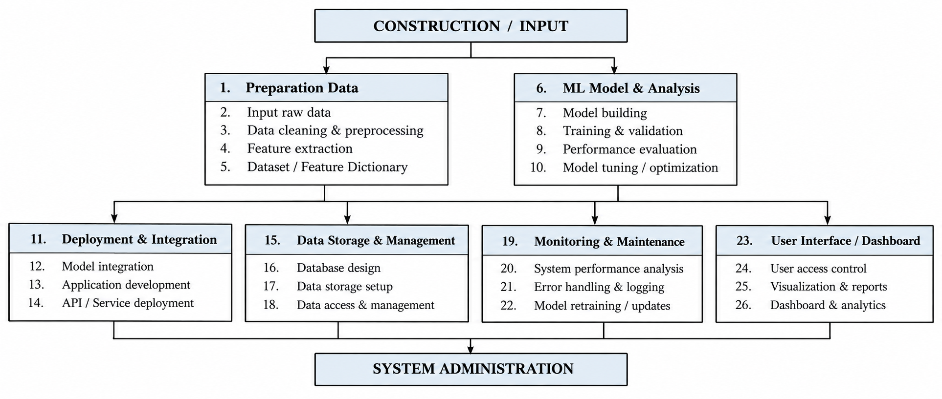
2. DFD Level 1: Operational Component Pipeline
The Level 1 representation decomposes the MERN-based stock trading platform into authentication, market, trading, portfolio, and administration workflows, showing how requests move between application processes and MongoDB data stores.
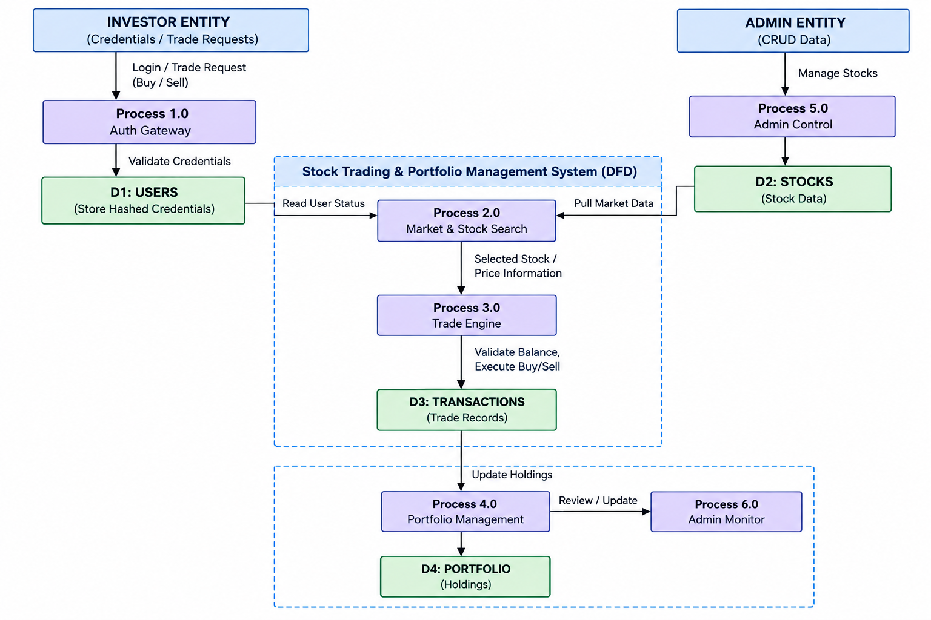
3. Data Flow Diagram Entity and Process Dictionary
Element Identifier | Typology | Description & System Interactivity | Technology Mappings
Investor / User | External Entity | Registers and authenticates, searches stocks, submits buy/sell requests, and views portfolio, profit/loss, and transaction history. | React.js Frontend SPA
System Administrator | External Entity | Reviews platform activity, manages stock records and users, and monitors/moderates transactions through protected administration features. | Secured React Admin Interface
Process 1.0 | System Process | Processes registration and login requests, verifies credentials, hashes passwords, and issues secure JWT authentication tokens. | Express.js Middleware + JWT + bcrypt.js
Process 2.0 | System Process | Provides stock browsing, search, market information, price updates, and stock-detail data through backend APIs and external market-data integration when configured. | Node.js/Express REST API + Axios
Process 3.0 | System Process | Validates buy/sell requests, checks available virtual balance and quantity, calculates trade value, and records successful simulated trades. | Node.js/Express Trading Services
Process 4.0 | System Process | Updates holdings, average purchase values, available balance, current portfolio value, and profit/loss after completed trades. | Node.js Services + MongoDB
Process 5.0 | System Process | Provides authorized administrators with create, read, update, and delete operations for stocks and controlled management of users and transactions. | Admin-Protected Express Routes
Process 6.0 | System Process | Monitors transaction activity, user activity, stock data, and administrative moderation/status information. | Admin Dashboard + Express APIs
D1: Users Collection | Data Store | Persists user profile information, hashed credentials, roles, and authentication-related account data. | MongoDB + Mongoose
D2: Stocks Collection | Data Store | Stores stock symbols, company names, current prices, daily statistics, and historical market information. | MongoDB + Mongoose
D3: Transactions Collection | Data Store | Stores buy/sell transaction records including user, stock, quantity, price, transaction type, total amount, and timestamp. | MongoDB + Mongoose
D4: Portfolio Collection | Data Store | Maintains user holdings, available balance, average purchase price, current value, and profit/loss summary. | MongoDB + Mongoose

